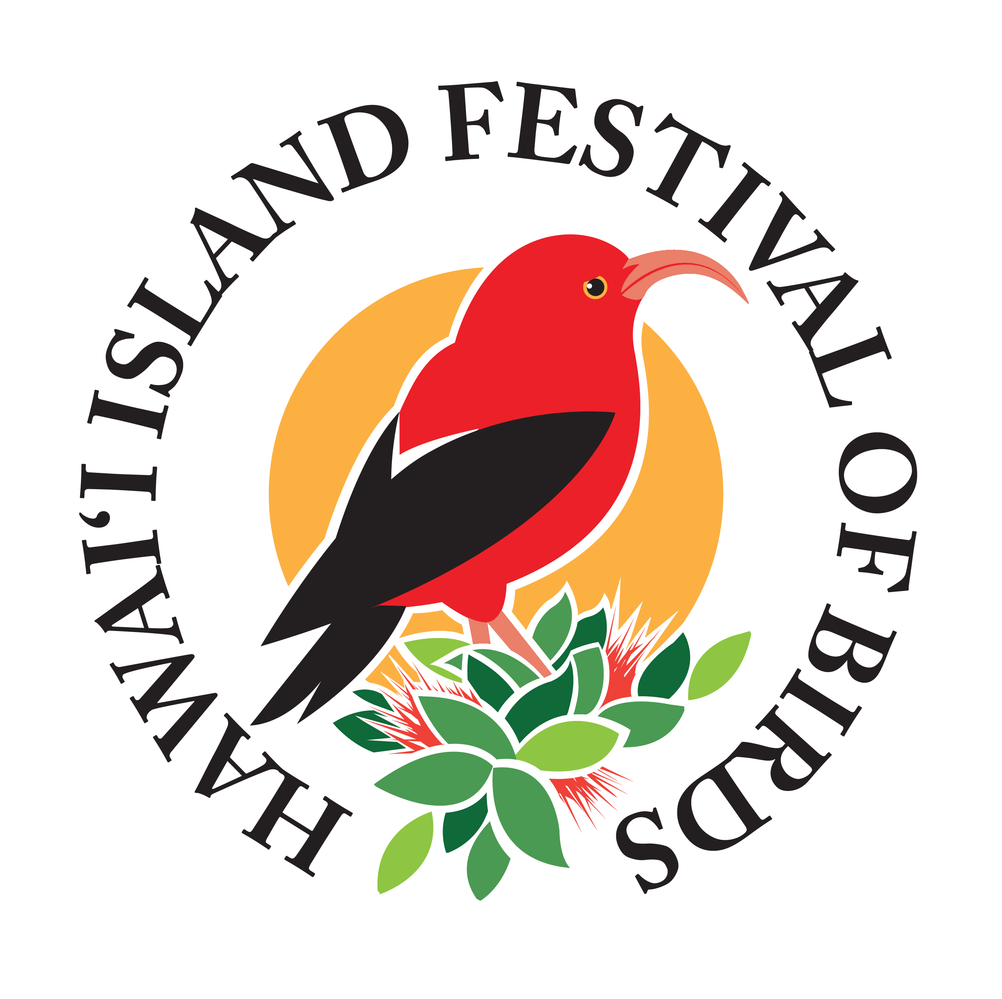
Hawai‘i Island Festival of Birds – Ha‘akula Manu
P.O. Box 551752 Kapa‘au, HI 96755 | (808) 884-5000 | EIN 20-1489691

Registration Form
Please fill out this form and email the document to info@birdfesthawaii.org.
Online registration is also available at https://forms.gle/fYYCeqy3Zu8HXA9W6

Hālau Name:

Hālau Home Base:
Where will you be joining us from?

Point of Contact (POC):

POC Email:

POC Phone Number:

Hula Mele or ‘Oli name:

Bird or Birds featured in your hula mele or ‘oli (Must be species native to Hawai‘i):

Kaʻao or Story or Themes in your Presentation
Please share a narrative that can accompany our program

Audio Needs
Will the mele or ʻoli be live or pre-recorded? How many microphones or instrument plug-ins are needed, if any?

Will you need a dressing room?:
Hālau members are encouraged to come ready to present their hula. However, if you will need dressing room space, please let us know.

Special requests (Optional)
We will consider all requests and try to accommodate what we can, but cannot guarantee requests will be granted.

